Adrian Grimm

Chapter 8 Hands On Assignment

1. SELECT Lastname, Firstname, state

FROM Customers

WHERE State = 'NJ';



2. SELECT Order#, ShipDate

FROM Orders

WHERE ShipDate > '01-APR-2009';

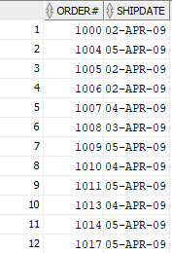

3. SELECT Title, Category

FROM Books

WHERE Category != 'Fitness';

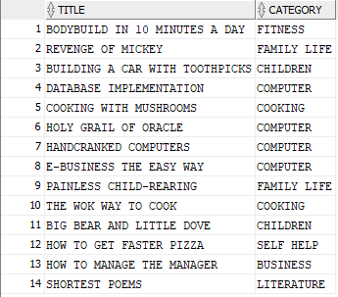

4. SELECT Customer#, LastName, State

FROM Customers

WHERE State IN ('GA','NJ')

ORDER BY LastName;

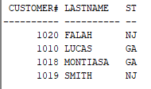

SELECT Customer#, LastName, State

FROM Customers

WHERE State = 'GA' OR State = 'NJ'

ORDER BY LastName;

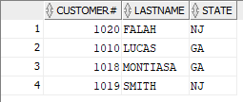

5. SELECT Order#, OrderDate

FROM Orders

WHERE OrderDate <= '01-APR-2009';

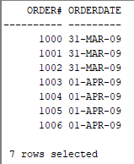

SELECT Order#, OrderDate

FROM Orders

WHERE OrderDate <= '01-APR-2009'

ORDER BY Order#;

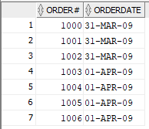

6. SELECT Lname, Fname

FROM Author

WHERE Lname LIKE '%IN%'

ORDER BY Lname, Fname;

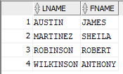

7. SELECT Lastname, Referred

FROM Customers

WHERE Referred IS NOT NULL

ORDER BY Lastname;

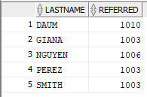

8. SELECT Title, Category

FROM Books

WHERE Category LIKE 'C%I%';

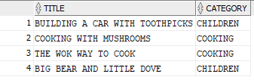

SELECT Title, Category

FROM Books

WHERE Category = 'CHILDREN' OR Category = 'COOKING';

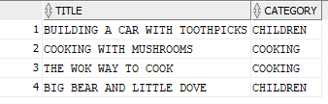

SELECT Title, Category

FROM Books

WHERE Category IN ('CHILDREN','COOKING')

ORDER BY Category;

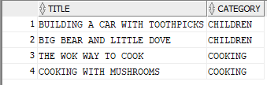

9. SELECT ISBN, Title

FROM Books

WHERE Title LIKE '_A_N%'

ORDER BY Title DESC;



10. SELECT Title, PubDate

FROM Books

WHERE Category = 'COMPUTER' AND PubDate LIKE '%05';

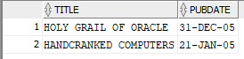

SELECT Title, PubDate

FROM Books

WHERE Category = 'COMPUTER' AND PubDate BETWEEN '01-JAN-05' AND '31-DEC-05';



SELECT Title, PubDate

FROM Books

WHERE Category = 'COMPUTER'

AND PubDate >= '01-JAN-05' AND PubDate <= '31-DEC-05'

ORDER BY PubDate;

